1. First run the following command before running the file **“pip install -r requirements.txt”.** It will install all the required packages of python fot this project.
2. Open Runner.ipynb File

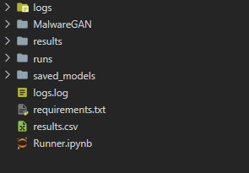

1. Inside Run Each Cell OF the file .
2. Section Are Mention for Each Code Portion example –
   1. Trainer to train the model

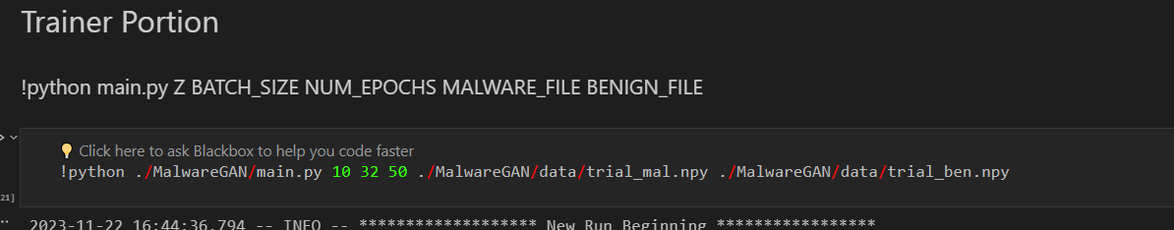

* 1. Benchmark to Benchmark on saved results

